Ant Esports ICE-280TG Gaming Cabinet

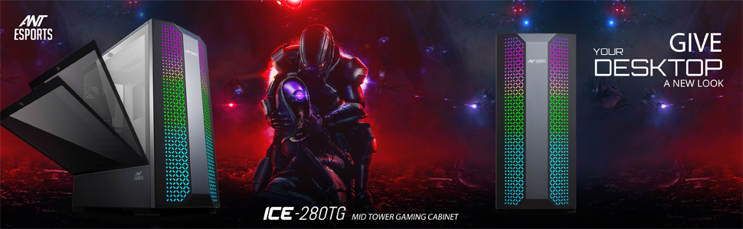

Ant Esports ICE 280 TG is as unique as it gets with its front honeycomb-like mesh design that lights up in all its glory when paired with RGB or ARGB fans in the back. The front mesh is perforated for abundant airflow while having a thin layer of the air filter to keep your build sparkling clean all the time. You are bound to be noticed with the ICE 280 TG thanks to its unique looks and ample housing capacity ranging from an ITX to a full ATX motherboard, eight 120mm fans out of which one black fan comes preinstalled at the back, and a full PSU shroud gives it a complete look much needed for your premium build.

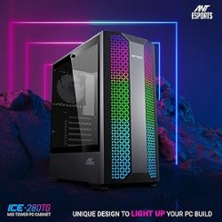   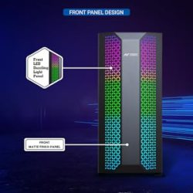    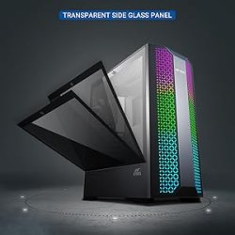

On the cooling side, you can either opt for air cooling with up to 160mm clearance or a 240mm radiator in the front and 120mm in the back. As for storage, the options are plenty and the user can either go with two HDDs or two SSDs or can opt for four SSDs and one HDD. The perforated PSU shroud enables decent airflow from the bottom and aids in optimum wire management and comes with dual magnetic dust filters to keep your build clean all the time when viewed from the tool-less side tempered glass panel.

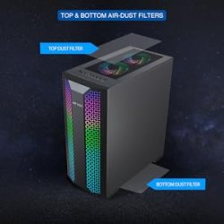   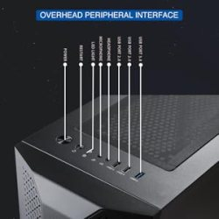    

The ICE aka Innovative Cooling Equipment, lineup promises to bring unmatched cooling, uncompromised quality, and unconventional RGB lighting to the reach of every gamer. Designed and created with utmost precision keeping in mind the need of every system builder alike the ICE series guarantees not only to elevate your system performance but also to keep you ahead in the heat of battle with its efficient cooling and sturdy construction.

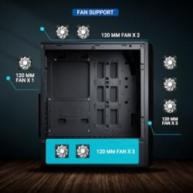   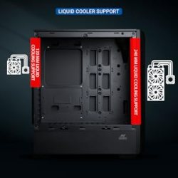    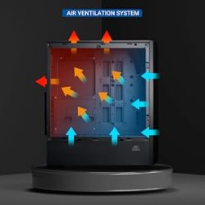

|  |  |  |
| --- | --- | --- |
| Dimensions ( L x W x H ) | Chassis Size | 365 x 205 x 440 mm |
| Packing Size | 512 x 272 x 500 mm |
| Motherboard Type | | ATX, Micro-ATX |
| Drive Bays | 3.5 Inch | x 2 |
| 2.5 Inch | x 2 |
| 5.25 Inch (External) | None |
| Fan Support | Front | 120 mm x 3 |
| Top | 120 mm x 2 |
| Bottom | 120 mm x 2 |
| Rear | 120 mm x 1 |
| Side | None |
| Liquid Cooling Support       (Maximum) | Front | 120 / 240 mm |
| Rear | 120 mm x 1 |
| Top | None |
| Pre-Installed Fans | x 1 Rear Fan | |
| Compatibility                     ( Maximum ) | VGA Card Length | 335 mm |
| CPU Cooler Height | 150 mm |
| I/O Panel | 1 x USB 2.0, 1 x USB 3.0, 1 x Audio In, 1 x Mic | |
| Expansion Slots | | 7 |